3 Color Full-color LED SMD Module

- Description：

RGB LED module is made up of a full-color LED SMD module, inputting PWM voltage through pin R, G, B to adjust the brightness of three colors (Red/blue/green) to achieve full color and mixed effect. Surely, Arduino module could makes it.

2. Specification

- Adopt 5050 full-color LED
- RGB is connected to limited current resistor to prevent from burning
- Adjust three basic colors through PWM to get different colors
- Compatible with all kinks of ports of single-chip controller
- Working Voltage：5V
- LED Drive Mode：common cathode drive

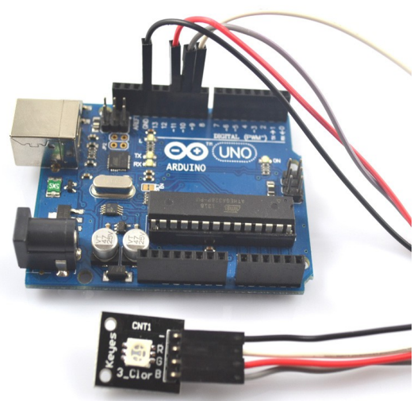

3. Arduino test code：

int redpin = 11; //select the pin for the red LED
int bluepin =10; // select the pin for the blue LED
int greenpin =9;// select the pin for the green LED
int val;
void setup() {
pinMode(redpin, OUTPUT);
pinMode(bluepin, OUTPUT);
pinMode(greenpin, OUTPUT);
Serial.begin(9600);
}
void loop()
{
for(val=255; val>0; val--)
{
analogWrite(11, val);
analogWrite(10, 255-val);
analogWrite(9, 128-val);
delay(1);
}
for(val=0; val<255; val++)
{
analogWrite(11, val);
analogWrite(10, 255-val);
analogWrite(9, 128-val);
delay(1);
}
Serial.println(val, DEC);

