

2D Scan Engine
DE2110 Specification

*Company: DongGuan DYscan Technology Co., Ltd
*Web: www.dyscan.com
*Tel: 86-755-21032537
*Add: 21st floor, Longsheng Times Building, Industrial Road, Longhua District, Shenzhen, 518000, China

Table of Contents
Product Description 3
Features 4
Application 4
Mounting 5
Host Interface Connector 6
Cable Interface 7
Performance 8
Physical Parameter 9
Environmental 9
Accessories List 10
Depth of field 10

Product Description
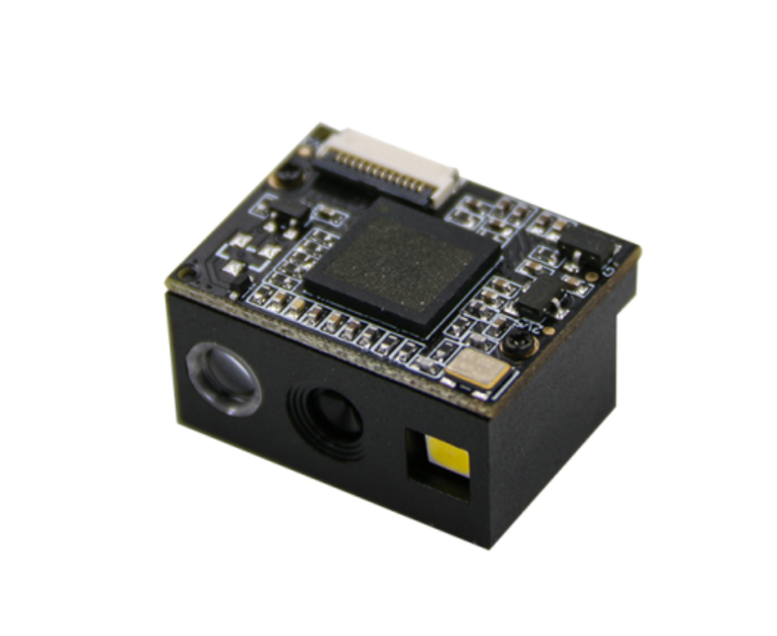
DE2110 is a practical embedded barcode scanner module with leading CMOS image recognition technology and intelligent image recognition system. It can scan universal 1D 2D codes, support USB, TTL multiple interfaces, read the paper, goods, screens, other media barcodes. Easily embedded in a variety of OEM products handheld, portable, fixed and barcode collector, etc.

Features
☆ Mini size, widely used in wireless machine, self-service terminal.
☆ Read all mainstream 1D 2D barcodes in the market easily. (4mil)
☆ Support USB barcode information transmission. ( languages customization)
☆ High brightness, dark environment scanning, low power consumption.
☆ Interface: USB, TTL.
☆ Support multiple systems and languages, secondary development.

Application
▅ Lockers | ▅ Mobile coupons, tickets
▅ Medical research | ▅ Mobile payment barcode scanning
▅ Lottery machines | ▅ Self-service terminals
▅ Queuing calling equipment | ▅ Self-service vending machines
▅ Microcontroller development
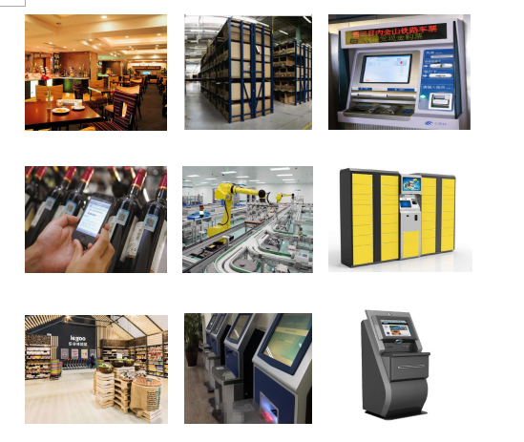

Mounting
The illustrations below show the mechanical mounting dimensions for the DE2110. The structural design should leave some space between components.
Front View（unit：mm）
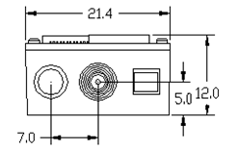

Top View（unit：mm）
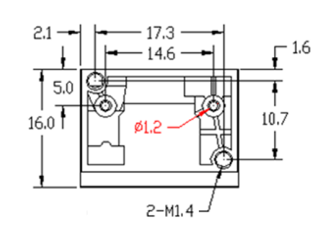

Host Interface Connector
The following table lists the pin functions of the ffc 12pin pitch 0.5,host interface connector on the DE2110
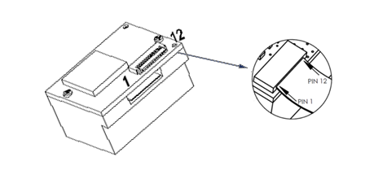
 | PIN# | Signal | Type | Definition
 | 1 | - | - | N/A
 | 2 | VCC | P | Power supply 3.3
 | 3 | GND | P | Ground
 | 4 | RXD | Input | TTL-RS232 receive
 | 5 | TXD | Output | TTL-RS232 send
 | 6 | D- | Input/Output | USB D- signal
 | 7 | D+ | Input/Output | USB D+ signal
 | 8 | - | - | N/A
 | 9 | BUZ | Output | Buzzer Output, free Low level
 | 10 | LED | Output | Decoding LED input signal, low level instruction reading codes successfully.
 | 11 | - | - | N/A
12 |  | TRIG | Input | Trigger pin, keep low power level can trigger decoding.

Cable Interface
DE2110 scanner must be connected with terminals, PC host, POS and Android host etc.
USB
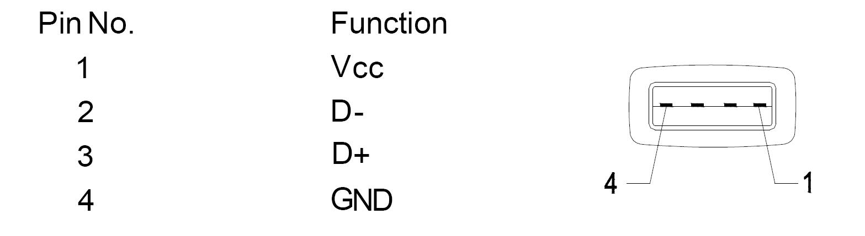

TTL/RS232
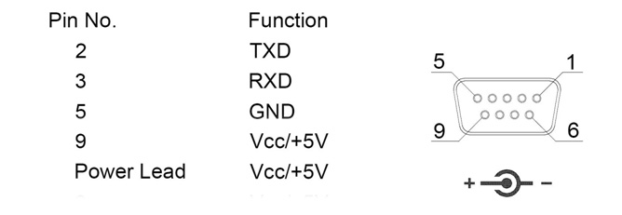

Performance
Scan Type | CMOS
Light Source | Red Light LED 625±10nm（aim), 5600K LEDs（ Lighting)
CPU | 32-bit
Resolution | 640*480
Reading precision | ≥4mil/0.1mm(PCS90%,Code 39)
Decoding speed | 25CM/S
Depth of field | 10mm-500mm
Scan Mode | Manual ,Continuous, Auto Sense
Scan angle | Test Conditions：CODE39,10mil/0.25mm,PCS90%
 | Pitch:±65°
 | Roll: ±360°
 | Skew: ±60°
Print Contrast Signal | ≥25%
Ambient Light | Dark environment, indoor natural light
Symbologies | 1D: UPC-A，UPC-E，EAN-8，EAN-13，ISSN，ISBN，Code 128， GS1-128，ISBT 128， Code 39，Code 93，Code 32, Code 11， Interleaved 2 of 5，Matrix 2 of 5，Industrial 2 of 5，Standard 2 of 5（IATA），Codabar（NW-7），Plessey，MSI Plessey，GS1-Databar（RSS），Itf-14，etc.  2D: QR Code, Data Matrix, PDF 417, Aztec Code, Maxicode, Hanxin. etc.

Physical Parameter
Weight | <6g
Dimension | (L)16.0mm * (W)21.4mm *(H)12.0mm
Communication Mode | USB(USB-KBW、USB-COM），TTL
Interface Type | FFC 12PIN Pitch 0.5
Power Supply | DC 3.3V@160mA(Max）,100ma(work)

Environmental
Operating temperature | -20℃ to 50℃
Storage temperature | -40℃ to 70℃
Humidity | 5% to 95%（non-condensing）
Drop Height | 1.2m
Temp. Test | 30 minutes for high Temp., 30 minutes for low Temp.,
High Temp. | 60℃
Low Temp. | -20℃
Transport vibration Test | 10H@125RPM

Accessories List
Cable（Optional） | USB Cable, used to connect the DE2110 to a host device.
 | RS232 Cable, used to connect the DE2110 to a host device, with USB supply cable.
Test board（Optional） | With trigger button and buzzer, it has USB or RS232 output function.
Power Adaptor | Output: DC5V 1A, input: AC100~240V 50~60Hz（serial port optional).

Depth of field
Barcode | Precision | near | far
Code 39 | 0.1(4mil) | 40mm | 130mm
Code 39 | 0.127mm(5mil) | 40mm | 150mm
Code 39 | 0.5mm(20mil) | 50mm | 400mm
Code 39 | 1.0mm(40mil) | 120mm | 500mm
EAN-13 | 0.33mm(13.0mil) | 50mm | 250mm
QR Code | 20.0mil | 10mm | 210mm
Data Matrix | 10mil | 20mm | 70mm
PDF 417 | 6.8mil | 20mm | 140mm
Test Condition：T=25℃，Illumination=200LUX，PCS=0.9

